PROJECT – 2 – AWS- PRODUCTION PROJECT

Final Goal
You will build:
User
|
|
Application Load Balancer
|
-------------------------
| |
EC2-1 EC2-2
| |
Docker App Docker App
|
Nginx Reverse Proxy

|
CloudWatch
|
SNS Alert

|
S3 Backup
Using:
- AWS EC2
- AMI
- Launch Template
- Auto Scaling
- ALB
- Docker
- Nginx
- IAM Role
- CloudWatch
- SNS
- S3
EBS

STEP 1:
LAUNCH AN UBUNTU EC2
Connect to it locally in power shell
Connect:
ssh -i "C:\Users\Rajeev\Desktop\new1.pem" ubuntu@ec2-3-139-73-222.us-east-2.compute.amazonaws.com
we gave users/Rajeev/desktop/new1.pem path because the new1.pem keypair is on desktop
You should see:
ubuntu@ip-xxx:~$

STEP 2:
INSTALL APPLICATION ENVIRONMENT (EC2)
Sudo apt update
Sudo apt upgrade –y
INSTALL DOCKER
Sudo apt install docker.io –y
Check docker version : docker –v
GIVING DOCKER PERMISSIONS
Now we need to give docker the root permissions
Here we are adding ubuntu user to docker group nd giving root access
Command: sudo usermod –aG docker ubuntu
Now exit and re-login to ssh session because the current terminal session dint know about the change, so when we re-login then its updated
Now give command docker ps, it works ( before giving permission it used to say permission denied when we ran the docker ps command)

STEP 3:
CREATE A SMALL FLASK APPLICATION
Y Flask? Because instead of writing code on regular HTML file, flask gives more flexibility
Flask is a python web framework. This is used to write the logic for the website
LOGOUT FROM EC2, go back to LOCAL SERVER
Create a new directory
Mkdir proj2-aws-prod-project
Cd proj2-aws-prod-project
Mkdir app
Cd app
Here create the files to write code
We are creating 3 files
- App.py : this has the application code
To start writing code : command: notepad app.py ( not vim as its local windows machine, and vim is only available in linux, ubuntu etc)
Code:
from flask import Flask

app = Flask(__name__)

@app.route("/")
def home():
return "AWS DevOps Project 2 - Application Running"

@app.route("/health")
def health():
return "Healthy"

app.run(host="0.0.0.0", port=5000)

Here,
from flask import Flask

We are writing this to import the flask framework

app = Flask(__name__)

We are writing this as it creates the flask application

@app.route("/")
def home():
return "AWS DevOps Project 2 - Application Running"

We are writing this @app.route("/")as This creates a URL endpoint.
Meaning:
When someone visits:
http://server-ip/
Flask executes:
home()

So when they come at home() the AWS Devops proj text will be displayed

@app.route("/health")
def health():
return "Healthy"

We are writing as whenever someone visits: http:/server-public-ip/health
Then it shows the Healthy text if ALB shows its healthy, if ALB shows unhealthy then it shows un-healthy

app.run(host="0.0.0.0", port=5000)
This starts the flask, and 0.0.0.0 so that everyone can access it locally and also adding port 5000 so that we can later map the docker to this port

- File 2: requirements.txt

Code:
flask

This will tell docker to install whatever is in requirements.txt before running app.py file

Now after saving give ls, cat and see if content is in file, if not there append using echo command on terminal nd then give cat

Command: echo flask > requirements.txt

- File 3: Docker File
Code:
Create Dockerfile:
Dockerfile
Content:
FROM python:3.10

WORKDIR /app

COPY . .

RUN pip install -r requirements.txt

CMD ["python","app.py"]

This file will create the docker image and using docker image we will create docker container
FROM python:3.10

This means It says start with linux image that has python 3.10 instead of manually installing python

WORKDIR /app

This means it says look into the app folder where we have the 3 files. Without this it looks into other folders

COPY . .

This copies all the 3 files from laptop into the container

RUN pip install -r requirements.txt

This command says install the dependencies that is the requirements.txt files so it will install flask as that’s written in that file

CMD ["python","app.py"]

Now Docker executed app.py file

If content is notgetting saved then append using echo command in terminal nd give cat command
@"
FROM python:3.11-slim
WORKDIR /app
COPY requirements.txt .
RUN pip install -r requirements.txt
COPY app.py .
EXPOSE 5000
CMD ["python","app.py"]
"@ | Out-File Dockerfile

Now check using cat command

NOW WE NEED TO PUSH THIS CODE TO GITHUB FROM LOCAL, SO THAT WE CAN CLONE THE REPO TO EC2 AND BUILD THE DOCKER IMAGE

Give ls and we can see the 3 files we created
Now give git init to initialize git

Now give: git add .

Now check: git status

Now commit: git commit –m “aishu did it”

Now open git hub and create the repo
After creating repo, you will get this commands in git hub, copy all the 3 to local:
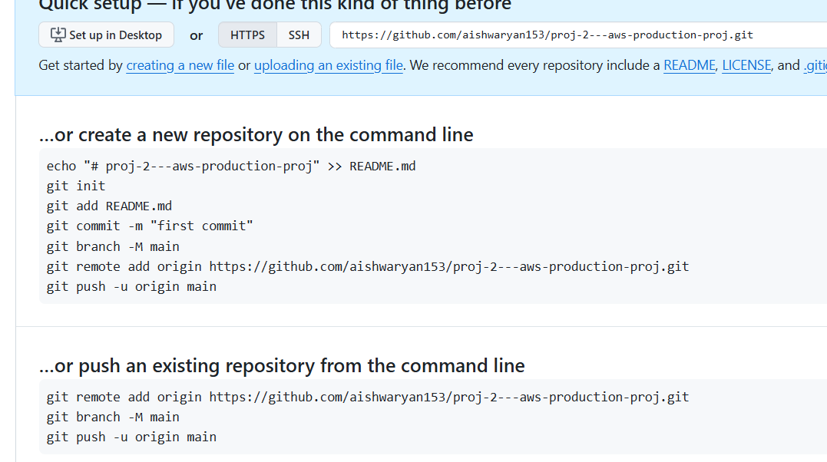
Now github has all the files
Now login to ec2 to build docker image

LOGIN TO EC2:

Give git clone command:

Git clone https://github.com/aishwaryan153/proj-2---aws-production-proj.git

Give ls and we can see the 3 files, now build docker image
Give docker images command. We can see the created docker image

Now from the created docker image, create the container which has the docker application
Command:

Docker run –d –p 5000:5000 proj2

Here –d for detach mode, -p is for port mapping and proj2 Is the image name
Now container is created which hosts the application

Validate:

Public ip:5000

Works you get the aws-devops-proj2 successful text

STEP 4

Install nginx reverse proxy

Y? Because flask is not designed to handle incoming traffic and users cannot go into website typing port number. So when a request comes from user, it goes to nginx, then using reverse proxy it sends request to flask nd then application is displayed

Install nginx:

Apt install nginx –y

Systemctl start nginx
Systemctl status nginx

Create Nginx configuration

Command:
sudo nano /etc/nginx/sites-available/proj2
Why this location?
Nginx follows this structure:
/etc/nginx/
|
├── nginx.conf
|
├── sites-available
| |
| └── project2
|
└── sites-enabled
|
└── project2 (link)
sites-available stores configurations.
Paste this code :
server {
listen 80;
location / {
proxy_pass http://localhost:5000;
}
}
This means take all traffic on port 80 and / for all the links of website and then pass it on to docker container to flask internally

Now file is created, not enable the file

Sites-available folder has all the files of website configurations but nginx cannot use it, sites-enabled has the active files

Command:
sudo ln -s /etc/nginx/sites-available/proj2 /etc/nginx/sites-enabled/

now restart nginx:

systemctl restart nginx

now reload public ip page and you will get welcome to aws project 2 successful page

STEP 5
Create an AMI of this ec2 and launch a new ec2 using that AMI
Now login to that ec2, give public ip
You should see: AWS – proj 2 successful

If you cant see it then, login to ec2 , check docker ps –a , see if the containers shows exited,
Now restart the container : docker start container_id
Now reload the public ip page, you will get the website

STEP 6
Create load balancer for those 2 servers
Access using load balancer dns

STEP 7
Create Auto Scaling Group

STEP 8
MONITORING
We use cloud watch as without this we can just get few metric details but with this we can get full depth knowledge of our resources

First we will install cloud watch agent in our ec2 which will take metrics from ec2 and send to aws cloud watch so ec2 wants to send data to cloud watch so its interacting with aws so we need to give IAM role

Create a aws role with cloud watch agent server policy

Now attach this policy to the ec2

Now login to both ec2s, to get the metrics of both

Now install cloud watch agent in the ec2:
Download :
wget https://amazoncloudwatch-agent.s3.amazonaws.com/ubuntu/amd64/latest/amazon-cloudwatch-agent.deb
Install:
sudo dpkg -i amazon-cloudwatch-agent.deb

now create the config file:
sudo nano /opt/aws/amazon-cloudwatch-agent/etc/amazon-cloudwatch-agent.json

write the code:
{
"metrics": {
"metrics_collected": {
"mem": {
"measurement": [
"mem_used_percent"
]
},
"disk": {
"measurement": [
"used_percent"
],
"resources": [
"*"
]
}
}
},
"logs": {
"logs_collected": {
"files": {
"collect_list": [
{
"file_path": "/var/log/syslog",
"log_group_name": "project2-logs",
"log_stream_name": "{instance_id}"
}
]
}
}
}
}

Start the cloud watch agent:
sudo /opt/aws/amazon-cloudwatch-agent/bin/amazon-cloudwatch-agent-ctl \
-a fetch-config \
-m ec2 \
-c file:/opt/aws/amazon-cloudwatch-agent/etc/amazon-cloudwatch-agent.json \
-s

Verify: it should be running:
sudo systemctl status amazon-cloudwatch-agent

NOW, create sns topic to get email

Open sns, create topic standard - give topic name create create subscription protocol choose email give email id open you email click on confirm subscription ( check spam too)

Now go to cloud watch alarms create alarm metrics select ec2 pre-instance metrics select cpu utilization scroll down nd select the ec2 threshold static cpu >=50 select the added sns notification
Now go to ec2 install stress apt install stress –y stress copy command and give timeout seconds time and enter

Wait for sometime, you will get the email

STEP 9

Backup
Create S3 bucket:
Name: project2-backup-yourname
Enable:
- Versioning
- Encryption
Upload:
- logs
- configuration files ( all the 3 files we created)

